18 - 13 Feb 2023 (Helm, Grafana)

14 February 2023

18:17

**Agenda:**

Helm chart - how it helps deploy app

Monitoring - Grafana

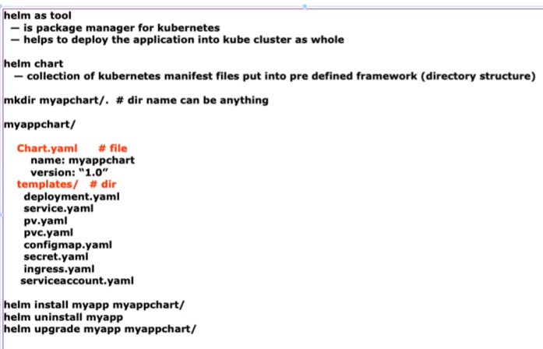

Install helm tool

<https://github.com/lerndevops/helm-charts>

curl -fsSL -o get_helm.sh <https://raw.githubusercontent.com/helm/helm/master/scripts/get-helm-3>  
chmod 700 get_helm.sh  
./get_helm.sh

helm version

Mkdir myappchart

Cd myappchart/

Touch Chart.yaml

Mkdir templates

Vi chart.yaml

apiVersion: v2 #by default always

name: myapp

version: "1.0"

descruotuibL "A Helm ch art for deploying …"

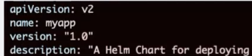

Move all yaml files created till now to templates folder.

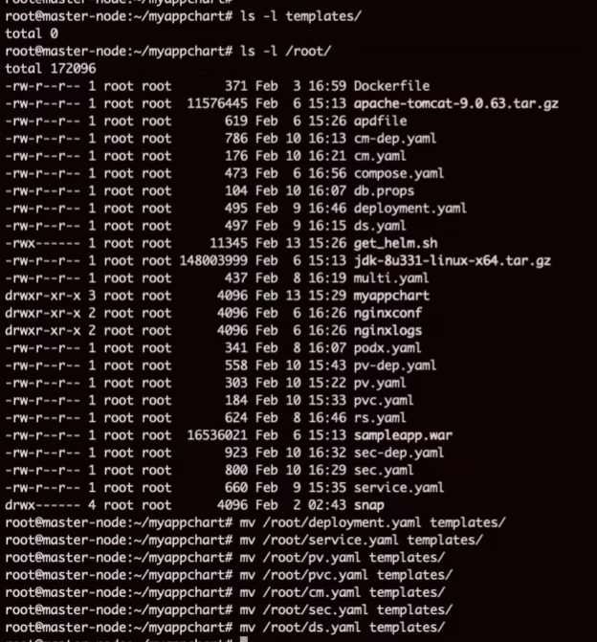

We are ready with now

Nothing created as of now

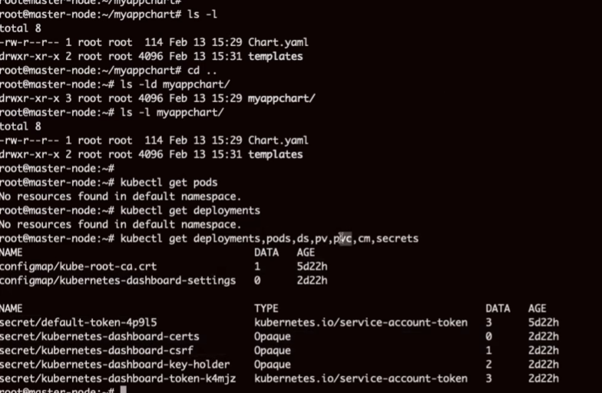

**How to apply this chart to cluster now?**

Helm list # to view list of help already present

|  |  |
| --- | --- |
| Helm install myapp myappchart/ | #install helm |

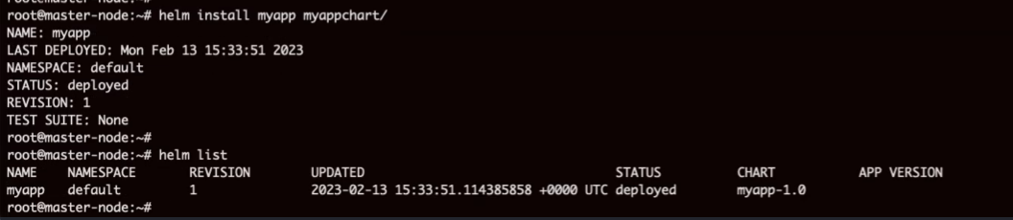

Check deployment status now

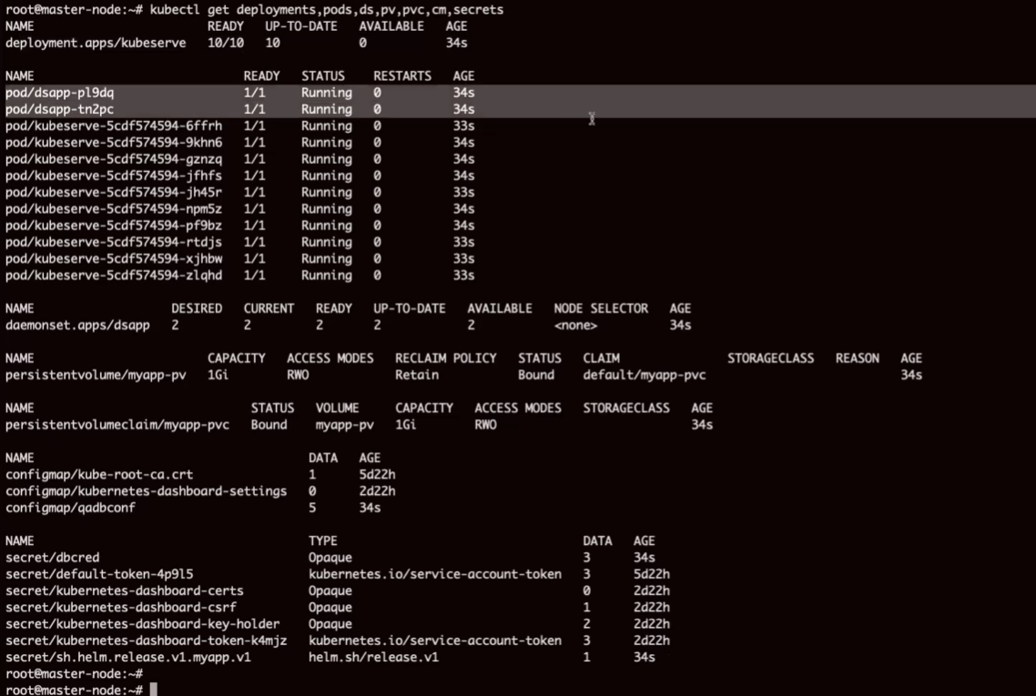

We can update any yaml file in templates/ folder. This is called update. This upgradeis done with this command

Helm upgrade myapp myappchart/

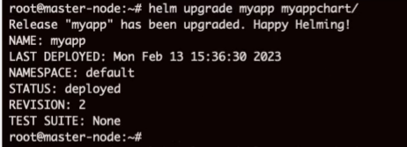

If I want to undo

Help uninstall myapp

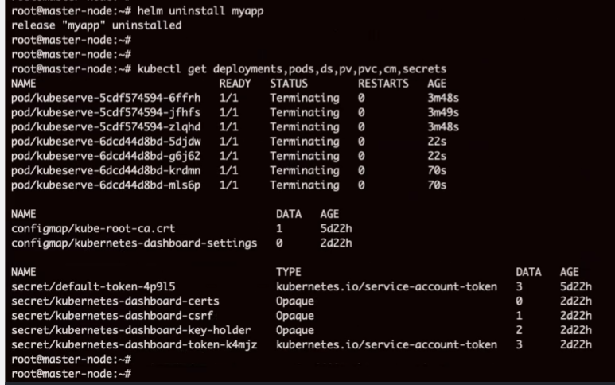

Yaml files keeping on local server is not a good idea.

Keep them in centralized repository like Git.

Helm charts for practice

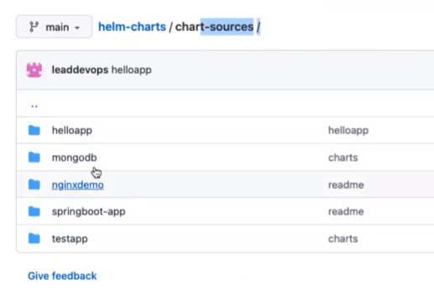

**How help connects to online repo**

helm repo add <REPO-NAME> <REPO-URL>

**helm repo add lerndevops** [**https://lerndevops.github.io/helm-charts/**](https://lerndevops.github.io/helm-charts/)

helm repo update

Note: REPO-NAME can be any value

|  |  |
| --- | --- |
| Helm repo list | #Shows repo list |
| helm search repo lerndevops | #shows list of charts available in repo |
| helm install nginxdemo lerndevops/nginxdemo | #installs chart |
| helm pull lerndevops/nginxdemo --untar --untardir /tmp | #download chart |
| helm uninstall nginxdemo | #uninstall |
| <https://artifacthub.io> | This portal will help on quick understanding on how to use charts.  Read the code and make modification as per our need. |
|  |  |

# Learned till now



 